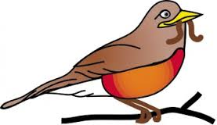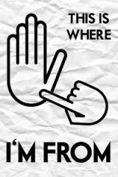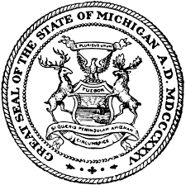

“The ABC’s of Michigan”

An Alphabet Book Project

Hello Families,

Today your child is bringing home a social studies project that was introduced today and is due on **Friday, November 4th**. This gives your child almost four full weeks to complete the project. We will work on the project at school, but some time will be needed at home to create the finished product. The planning page will also receive a grade and is due on **Friday, October 14th**to ensure everyone is on track.

Your child is being asked to create an ABC book about the great state of Michigan. Each letter of the alphabet will get its own page and must include: the letter of the alphabet, a picture of some kind, and a fact given in the form of at least one complete sentence. Your child will be given their blank book next week, but until then we are doing research that you can help with at home. Your child has a planning sheet that needs to be filled out and approved by us before beginning the final project. Please know there is a collection of web sites, under the Social Studies tab on the classroom web site, that we will use to gather most of our information. In addition, our Michigan social studies book is a great resource!

These student created books can be as simple or elaborate as you and your child like. The rubric for this project is on the back of this letter and you can see that the focus is on the basics and not many “style” points. Hand drawn pictures or Internet photos are both great and will earn the same points. Please know that the main focus will be on the information and how it is presented compared to how fancy it looks. I hope you enjoy helping your child with this project and please know that work time and supplies will be provided at school. Remember, mark your calendars for **November 4th**, but know that your project may be turned in as soon as it is done.

Mrs. Featherman