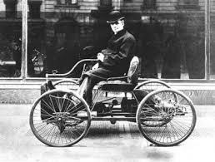



December 16, 2013

Dear Families,

Students are working on their ABC books for Michigan in Social Studies class. If you could please **send your child in with a small school photo of him/herself by Thursday, December 19th**, it would be appreciated! **Please note that you will NOT receive this photo back,** as it will be used on a page within your child’s book. If you do not have a photo to spare, your child can just draw a picture of him/herself in school on their page (on Thursday). Thank you!

Sincerely,

Mrs. Peacock & Mrs. Hansen

December 16, 2013

Dear Families,

Students are working on their ABC books for Michigan in Social Studies class. If you could please **send your child in with a small school photo of him/herself by Thursday, December 19th**, it would be appreciated! **Please note that you will NOT receive this photo back,** as it will be used on a page within your child’s book. If you do not have a photo to spare, your child can just draw a picture of him/herself in school on their page (on Thursday). Thank you!

Sincerely,

Mrs. Peacock & Mrs. Hansen

December 16, 2013

Dear Families,

Students are working on their ABC books for Michigan in Social Studies class. If you could please **send your child in with a small school photo of him/herself by Thursday, December 19th**, it would be appreciated! **Please note that you will NOT receive this photo back,** as it will be used on a page within your child’s book. If you do not have a photo to spare, your child can just draw a picture of him/herself in school on their page (on Thursday). Thank you!

Sincerely,

Mrs. Peacock & Mrs. Hansen